 

**PROJECT REPORT**

**_______________________________________________________**

**GAME DEVELOPMENT**

Name : Jeshiko J

Register Number : 960321104040

Department : CSE / 4th year

# **CONSTRUCT**

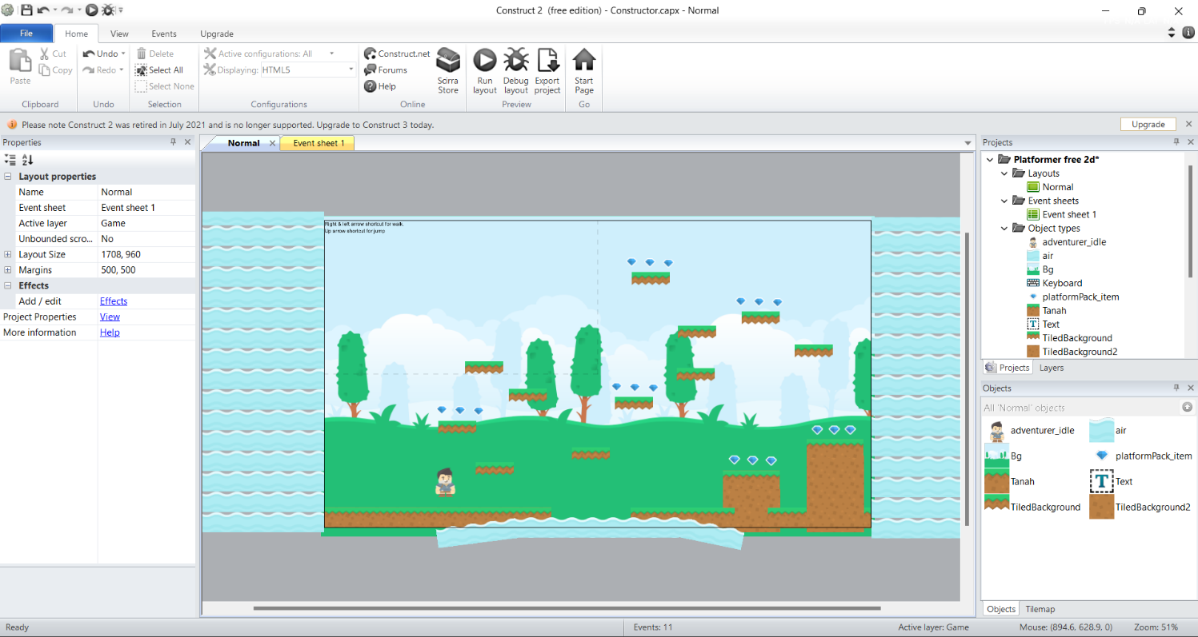

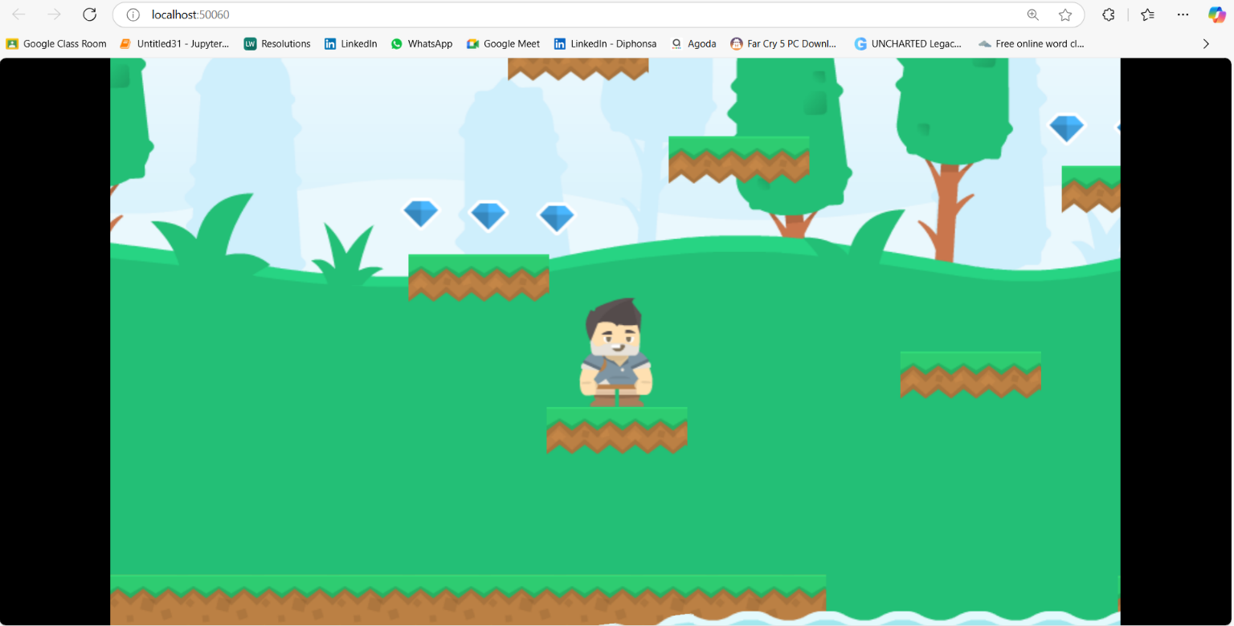

**BLENDER 3D Model**

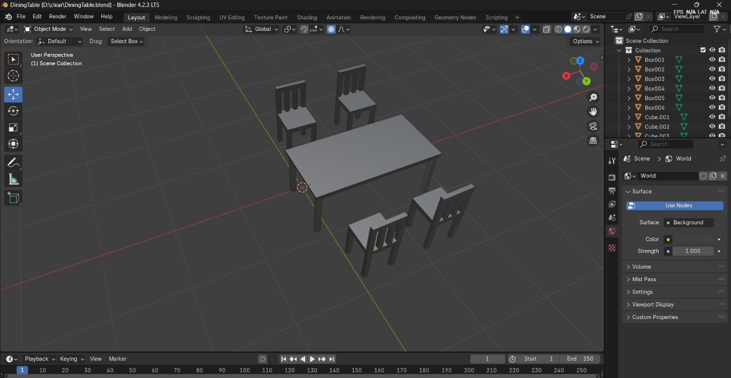

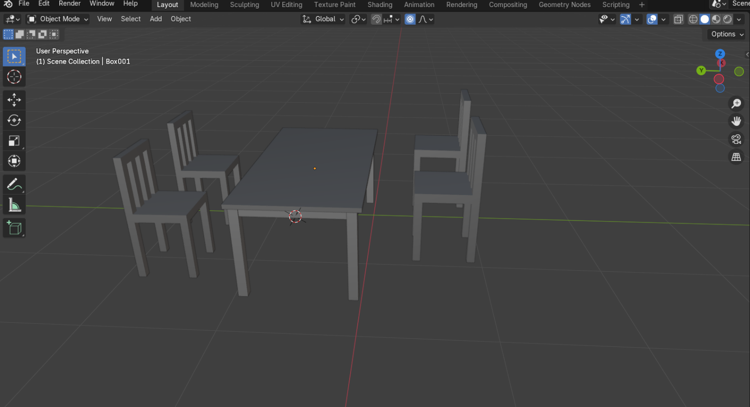

# **FLAPPY BIRD 2D GAME**

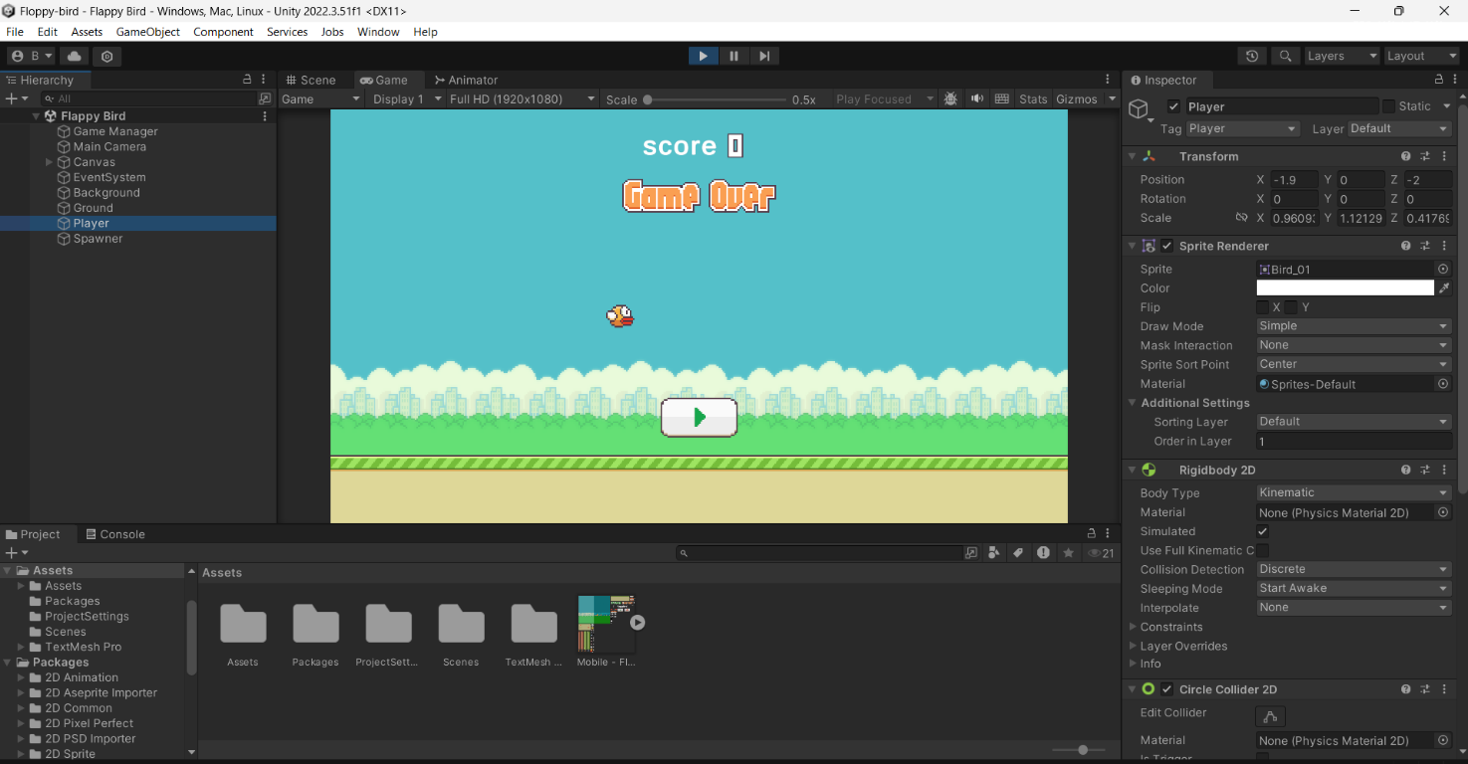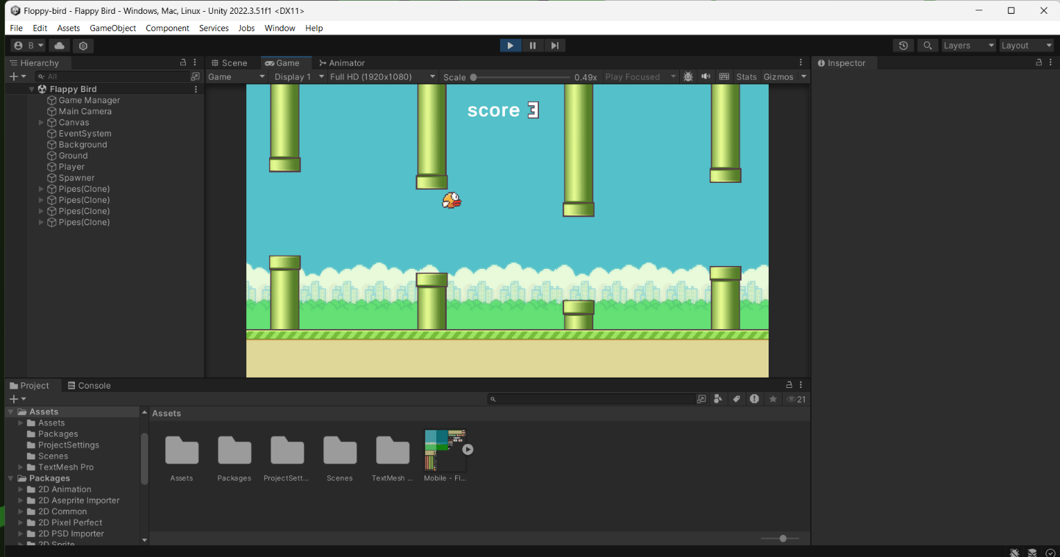

**CHARACTER CONTROLLER**

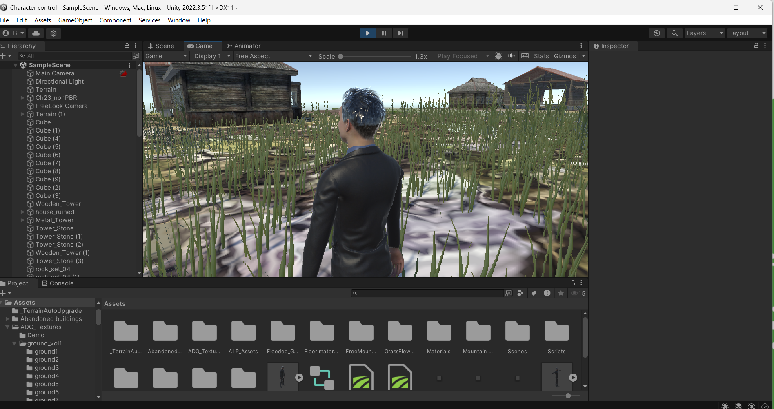

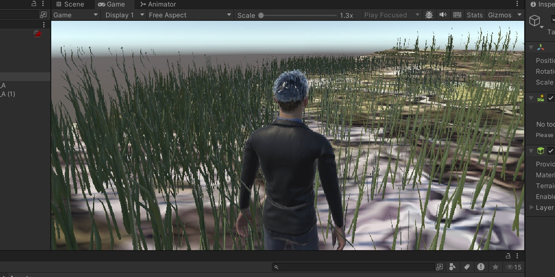

# **CAR 3D GAME**

